**Point Cloud Annotation Protocol**

This document contains the protocol used to annotate point clouds for quality control and segmentation purposes. It follows the methodology outlined by [Hu et al., 2023.](https://arxiv.org/pdf/2104.04891.pdf)

**Materials:**

1. CloudCompare point cloud visualization software. Available [here.](https://www.danielgm.net/cc/)
2. Microsoft Excel or similar spreadsheet viewer.
3. Access to the Sample_Lidar_Data Purdue Box folder, preferably installed as a desktop app.
4. A mouse.

**Steps:**

1. After installing both CloudCompare and the Box desktop app on your computer, use the Excel spreadsheet subsample_roster in the Sample_Lidar_Data folder to determine the name and location of the point cloud file (.ply) you will be working with.
2. Launch CloudCompare and locate the file using the ‘Open’ button and navigating to the correct file path. The file name will begin with the characters ‘cr_’ and end with the point cloud’s plot ID. Note: ensure that the file type visible dropdown is set to ‘All (*, *)’. See below:

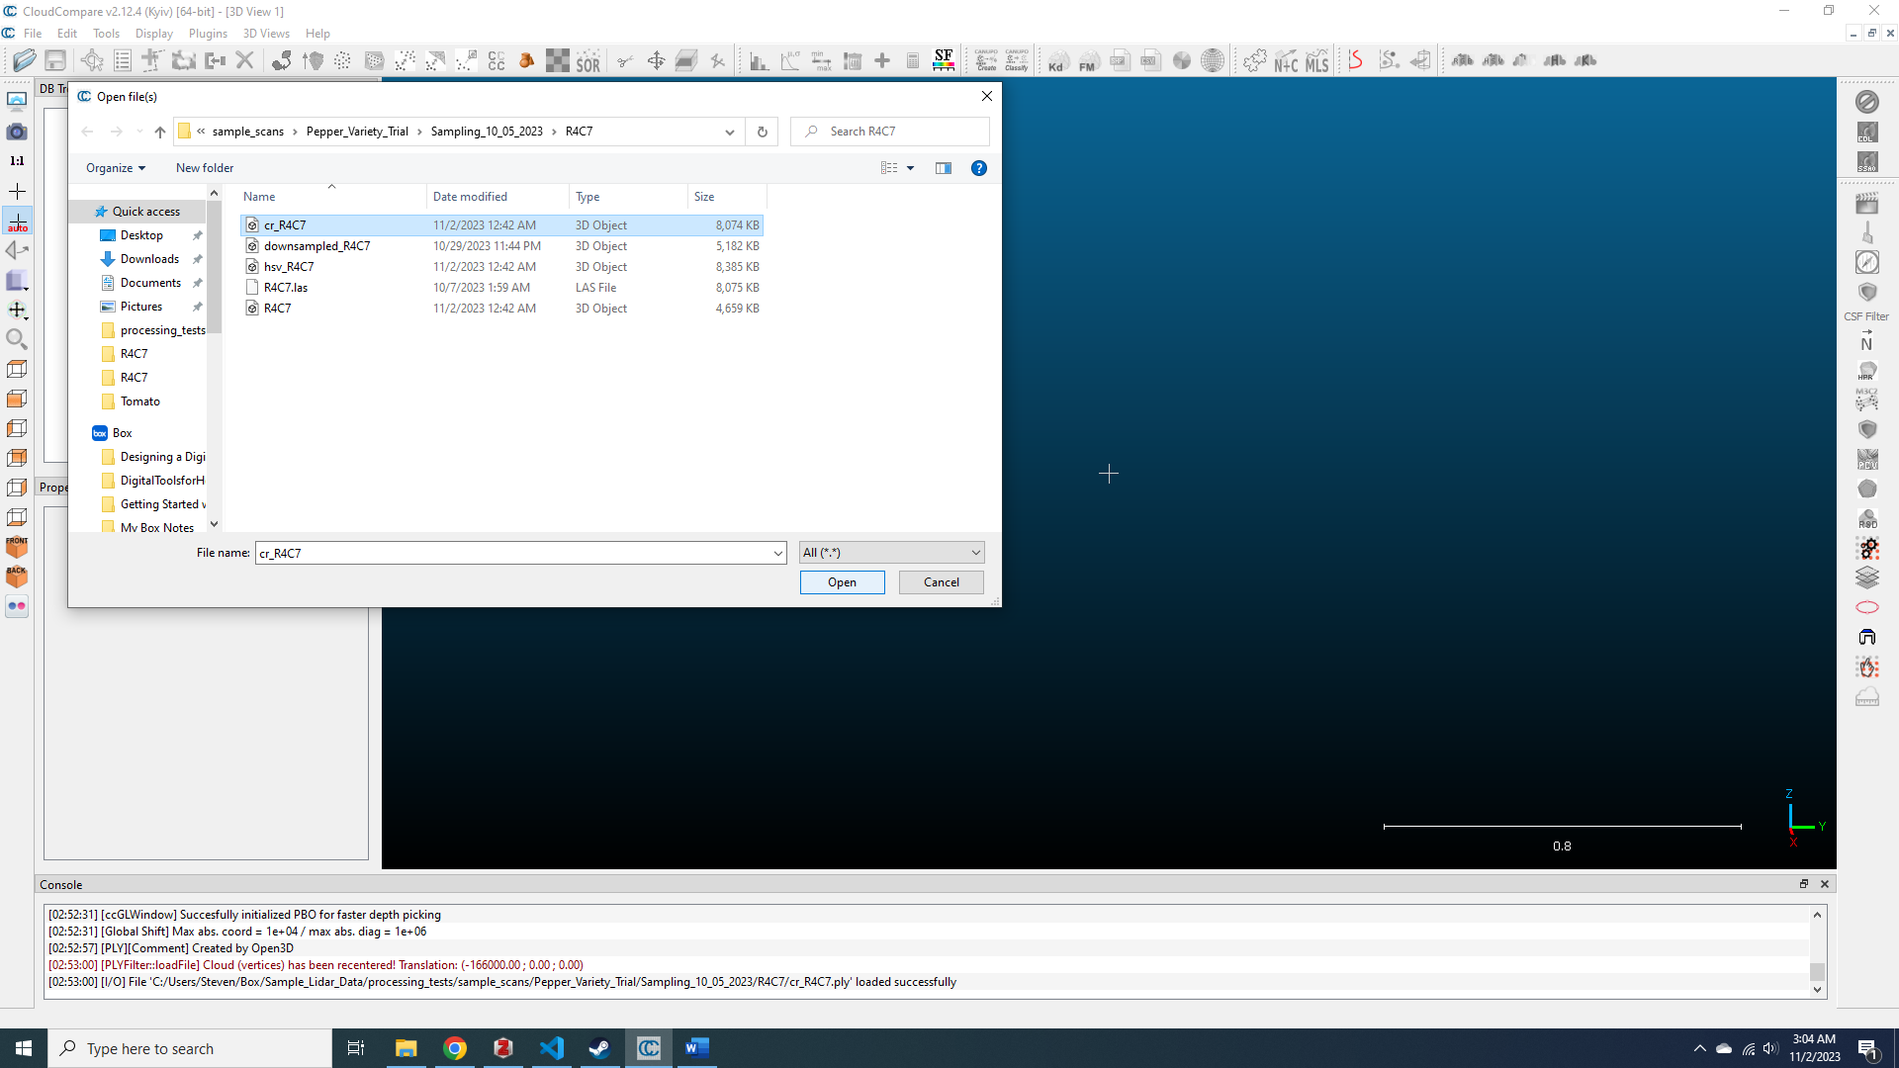

1. Once the file is open, you will see a point cloud containing one or more plants, as well as other items including the ground, trellises, grass, fruits, and outliers (like feet, parts of hands, or tape measures). Select the point cloud in the DB Tree pane on the lefthand side of the screen. Then click on the subsample button highlighted in blue below:

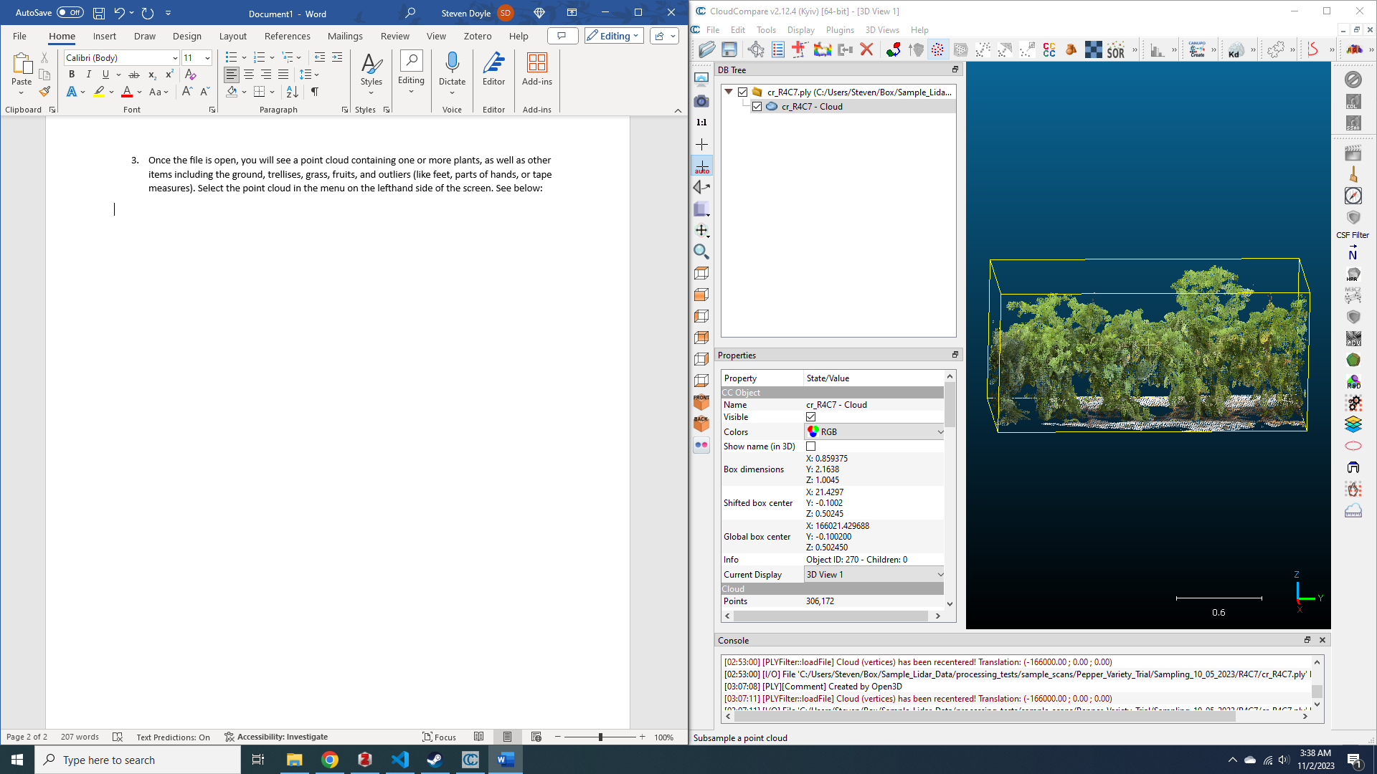

1. Set the sampling parameters to the ‘Random’ method and the remaining points to 0.1% of the original points. See below:

1. Once you click ‘Okay’, a new, subsampled point cloud should appear and the previous one will be unchecked in the DB Tree pane. Beneath this pane, in the Properties pane, scroll down to ‘Point size’ and adjust the dropdown to size 10, or another suitably large number of your choosing. Recheck the original point cloud and set its point size to a small value, for easy differentiation.

1. Right click on the plot’s folder in the DB Tree pane and select the ‘Add empty group’ option. Name it ‘ground’. Name another one ‘plant’. If any of the subsampled points include part of a trellis, fruit, or an outlier (part of a non-target plant or grass, measurement equipment like tape measures, the imager’s hand or leg, or true outlier points that have no nearby neighbors).
2. With the subsampled point cloud selected, open the ‘Segment’ tool, which can be found either as an icon of a pair of scissors in the above-screen toolbar, or under the ‘Edit’ dropdown menu. Draw a polygon around the portion of the subsampled cloud that you would like to segment using left clicks to add vertices and a right click when you are finished to exit the polygon. Select the ‘Segment in’ button on the Segmentation toolbar (or press ‘I’ on the keyboard) and then the green checkmark to confirm the segmentation (or press ‘Enter’ on the keyboard).

1. Place the newly segmented point cloud into its corresponding group.

1. Repeat these steps until every point is categorized.
2. Note: you may need to create multiple point cloud segments to produce a point cloud containing only a single category of points. In order to merge multiple point cloud segments into a combined cloud, you can press the ‘Merge multiple clouds’ button in the top toolbar, or find the ‘Merge’ option in the ‘Edit’ dropdown menu. When you click this button, you will be asked if you want to generate a scalar field with the original cloud index. PRESS NO! DO NOT PRESS YES OR YOU WILL NEED TO RESTART THE ENTIRE PROCESS.

1. For each resulting segmented point cloud, you will need to save it separately. Select the point cloud in the DB Tree pane and press the ‘Save’ button (or select ‘Save file’ under the ‘File’ dropdown menu). Name the segment using the following convention: [category]_[plot ID].ply. So the ‘ground’ point cloud for the plot ID R4C7 would be ground_R4C7.ply (note that the .ply file format should be selected from the ‘Save as type’ dropdown). When you click the ‘Save’ button, you will be asked if you would like to save the file in binary or ASCII format. Choose binary.

**Tips:**

* Label and save your categories in a consistent manner. There should only be plant, ground, fruit, trellis, and outlier categories for each point cloud. Some point clouds will have no fruit, trellis, or outlier categories at all.
* Keep track of the locations you open and save files to. When you save a segmented point cloud, you will have to manually navigate to the correct folder because CloudCompare does not keep track of the folder you loaded it from.